Snowflake Architecture & Cache with Practical Examples
1. Explain in your own words the three main layers of Snowflake architecture.
Practical:
Draw a simple diagram showing Storage, Compute (Virtual Warehouse), and Cloud Services . Explain what happens when you run a SELECT query.
Answer:

Storage Layer , Compute Layer , Cloud Services layer:

Cloud Services layer:
- Brain of Snowflake . Manages all coordination and metadata
Compute Layer (Virtual Warehouse):
- Virtual Warehouse = a cluster of compute resources . Executes SQL queries.

Storage Layer :
- Stores all data (tables, views, files) in compressed, encrypte micro-partitions.Uses cloud storage (AWS S3 / Azure Blob / GCP).
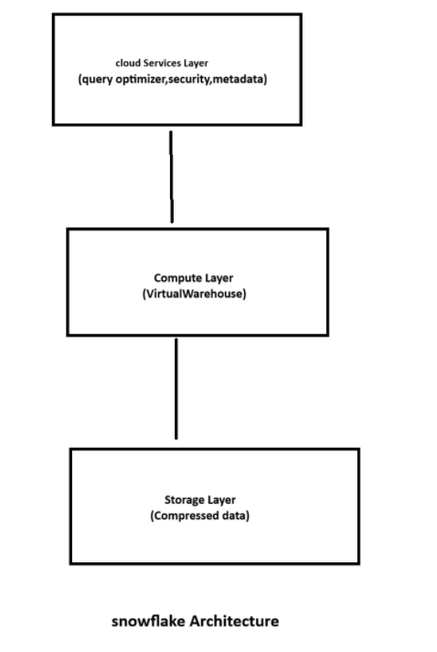
What Happens When You Run a SELECT Query?

SELECT * FROM EMPLOYEE;

- Snowflake separates storage, compute, and services so data is stored efficiently, queries run independently, and system management is fully automated.

2. What is the role of the Storage layer in Snowflake?
Practical:
Create a table and insert some data. Show how data remains stored even if the warehouse is suspended.
Answer:
First I created one table and also i insert some data:
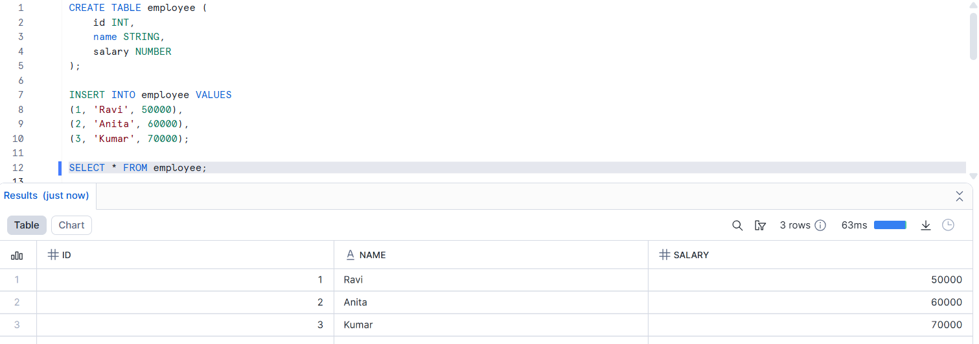
After i suspend a warehouse:
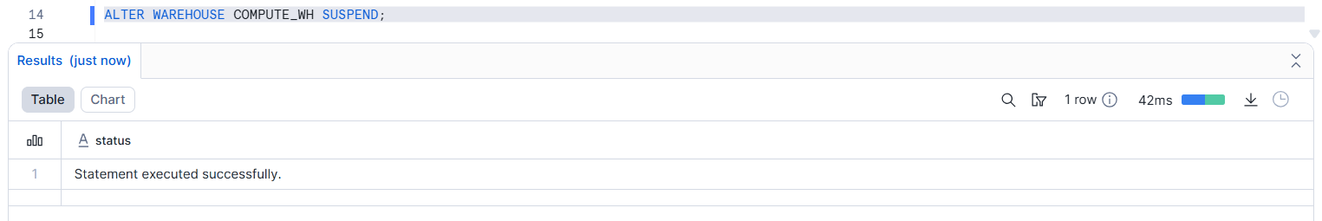
And also i resume and select the data in employee table:
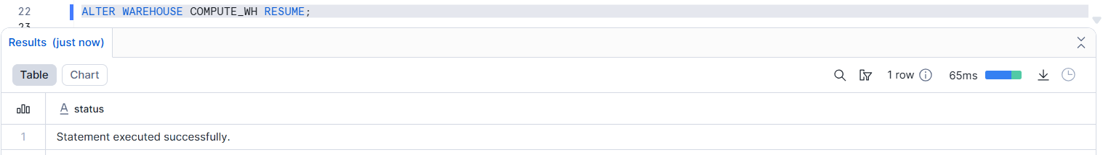
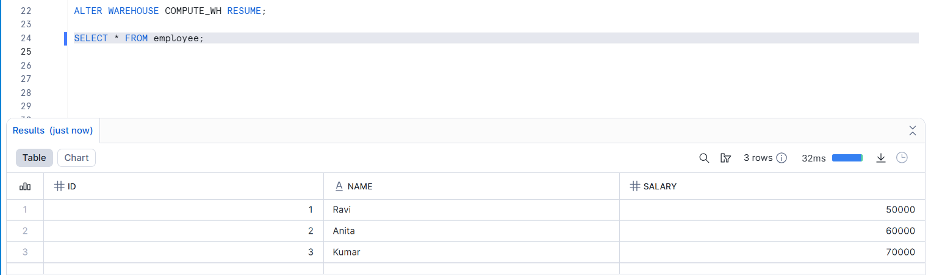
- Data is still available. This proves storage is independent of compute.
The Storage Layer in Snowflake securely stores compressed and encrypted data and remains available even when the Virtual Warehouse is suspended.

3. Describe what a Virtual Warehouse is in Snowflake.
Practical:
Create a warehouse, run a query, then suspend the warehouse. Show how warehouse size affects query speed by resizing it.
Answer:
A Virtual Warehouse in Snowflake is a compute engine used to execute SQL queries.
Create a warehouse:
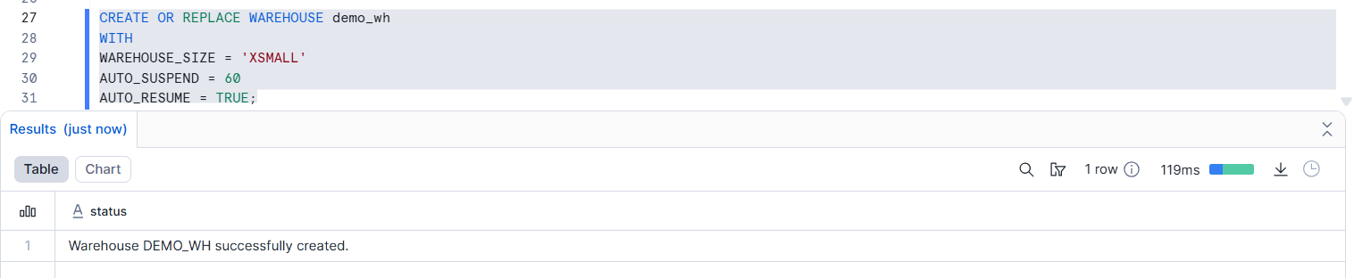
Run a query:
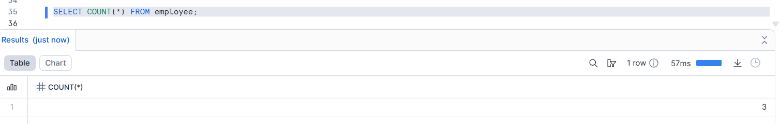
suspend the warehouse:
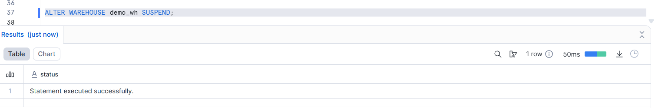
Resize Warehouse to Improve Query Speed:
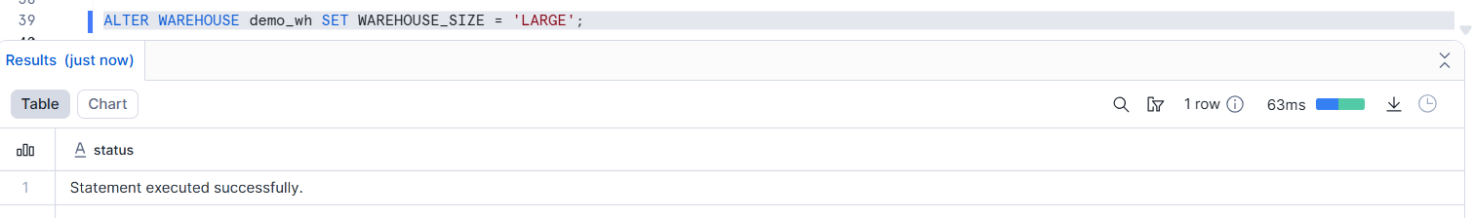
Run the Same Query Again:
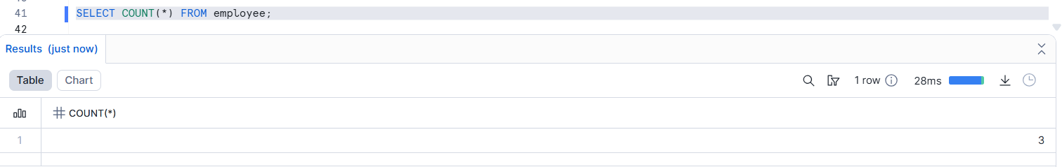
More size = more compute = faster queries
- A Virtual Warehouse in Snowflake is an independent compute cluster used to execute SQL queries and can be scaled or suspended without affecting stored data.

4. Explain micro-partitions and their importance.
Practical:
Run a query with a filter (e.g., WHERE AMOUNT > 1000) and explain how Snowflake reads only relevant micro-partitions to speed up the query.
Answer:
Micro-partitions are small, automatically created chunks of data in Snowflake’s Storage Layer.
Practical Demonstration - create table and insert data:
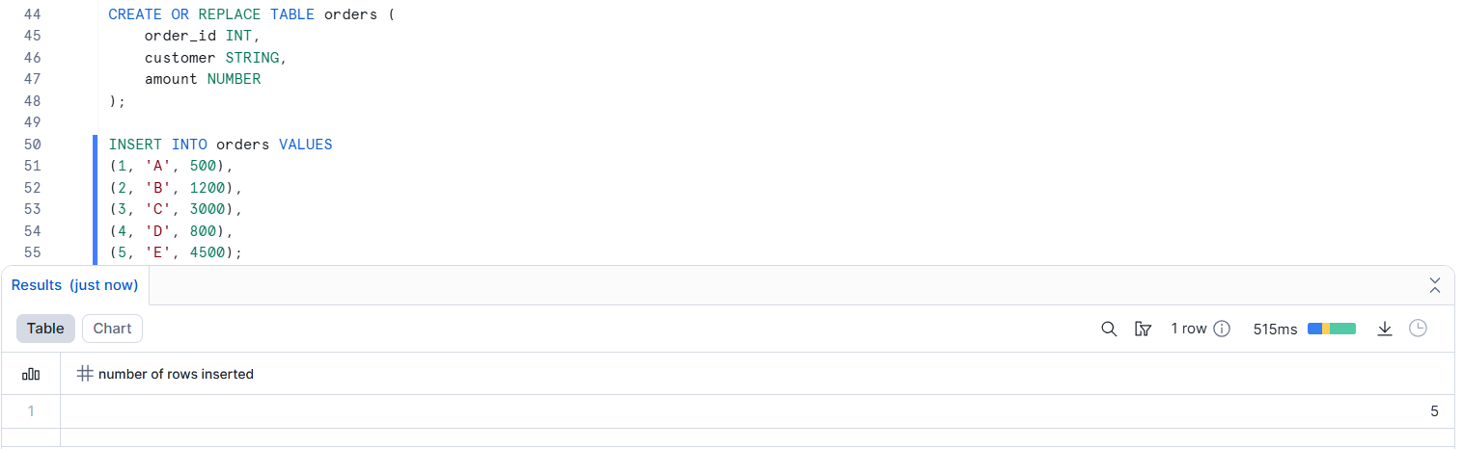

Run a Filtered Query:
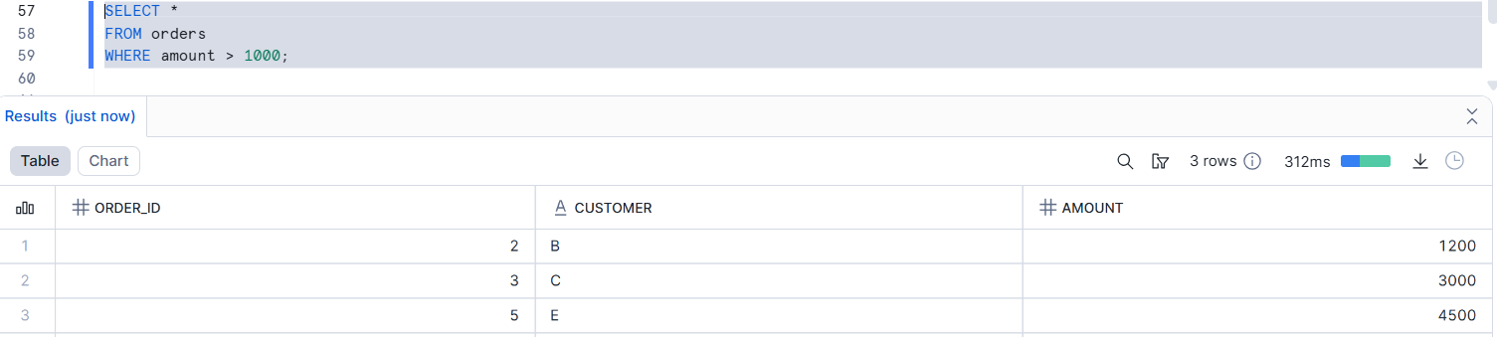
What Happens Internally:
- Data is already stored in micro-partitions
- Each micro-partition has metadata like:
MIN(amount)
MAX(amount)
Micro-partitions are small, automatically managed data blocks that allow Snowflake to scan only relevant data using metadata, significantly improving query performance.

5. What is the Cloud Services layer?
Practical:
Show a login process and role-based access in Snowflake. Explain how Cloud Services verify permissions before query execution.
Answer:
The Cloud Services Layer is the control and management layer of Snowflake.It acts as the brain that manages security, metadata, and query coordination.
First we check the user and role in current manner:
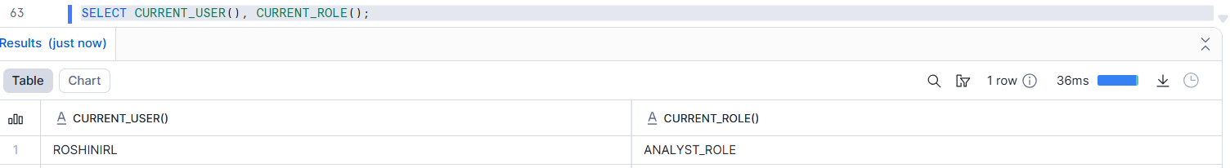
After creating one new role and grand the permission:
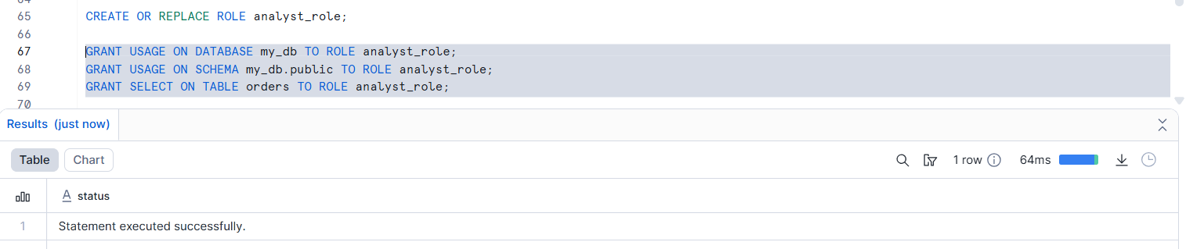
After we assign role to user and switch role:
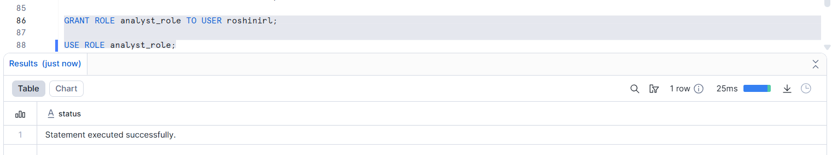
Run a Query:
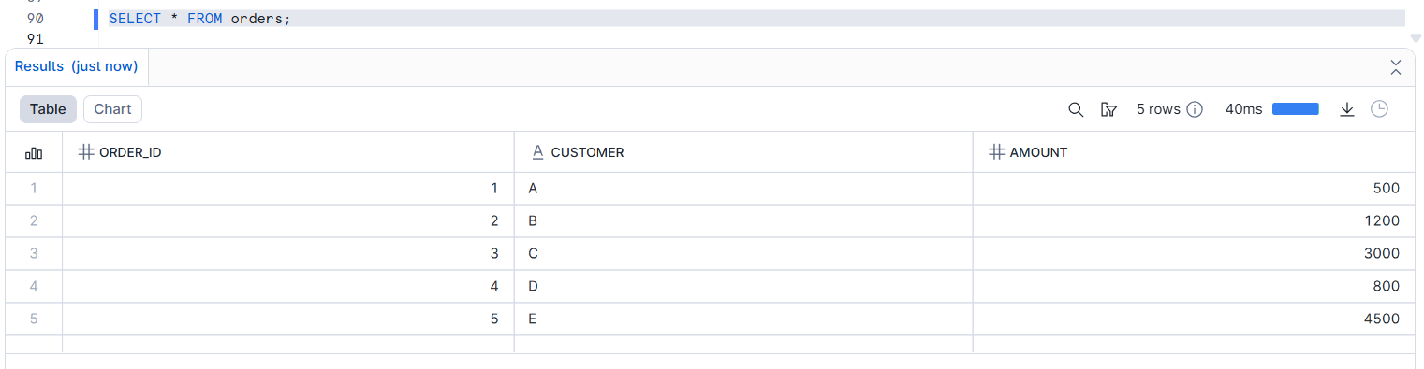
- The Cloud Services layer manages authentication, authorization, metadata, and query optimization, ensuring secure and efficient query execution in Snowflake.

6. Name and describe the three types of cache Snowflake uses.
Practical:
Run the same query twice and measure execution time to demonstrate Result Cache.
Restart warehouse and rerun query to explain Local Disk Cache.
Answer:
Snowflake uses three levels of caching to improve query performance and reduce cost.

6.1 Result Cache
- Stores the final result set of a query.
- Cached for 24 hours.
- No warehouse is used → zero compute cost.

Run query first time - Execution time: Longer (data read + processing)
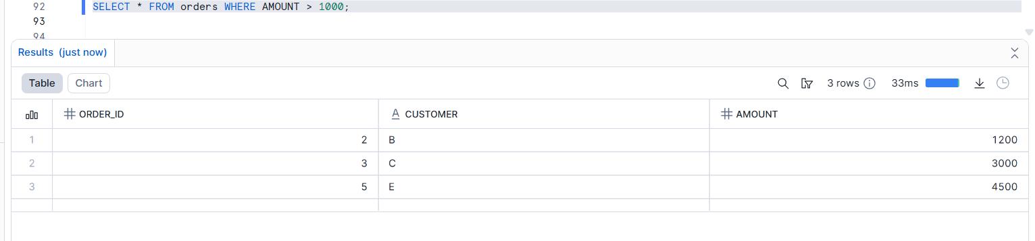
Run same query again - Execution time: Very fast (milliseconds)
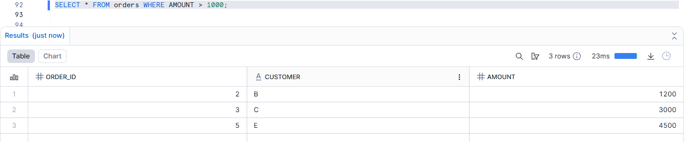

6.2 Local Disk Cache (Warehouse Cache)
- Data cached on the local SSD disks of a virtual warehouse.
- Stores micro-partition data read during previous queries.
Disable Result Cache - Run query in this Execution time is Moderate
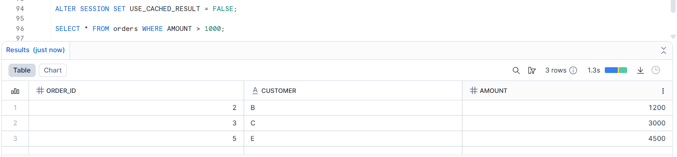
Run again - Faster than first run
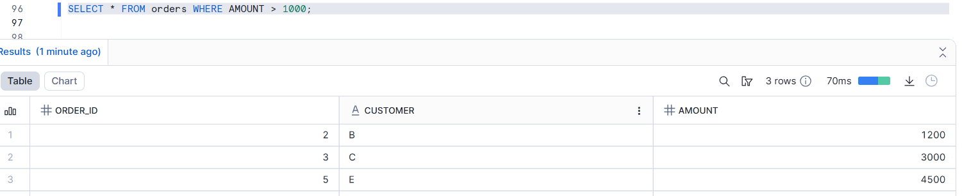

6.3 Remote Disk Cache (Cloud Storage Cache)
- Data stored in Snowflake’s central cloud storage (S3/Azure Blob/GCS).
- Always available.
The warehouse will restart in clear local cache.
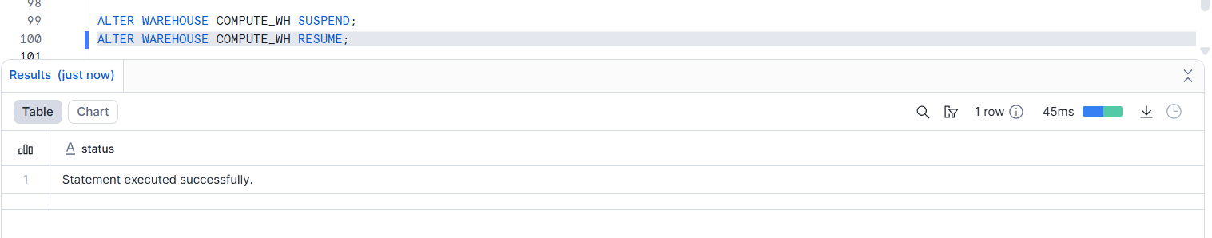
Run query again - Execution time: Slower again
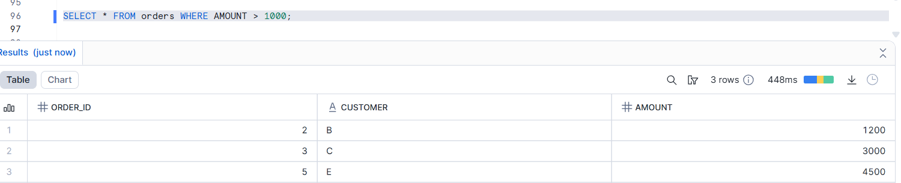
- Local Disk Cache is cleared when warehouse restarts.
- Snowflake now reads from Remote Disk Cache (Cloud Storage).

7. Explain Result Cache.
Practical:
Run a COUNT(*) query twice and note that the second run doesn’t consume compute resources
Answer:
Result Cache stores the final output of a query in the Cloud Services layer of Snowflake.
- Cached for 24 hours
- No virtual warehouse is used
- Returned instantly if the same query is executed again

Run Query First Time - Execution time: Slower
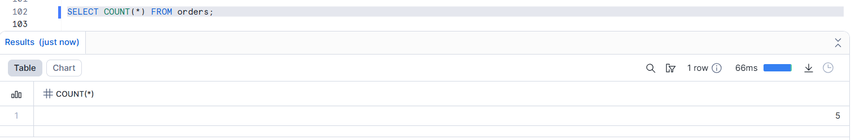
Run Same Query Again - Execution time : Milliseconds
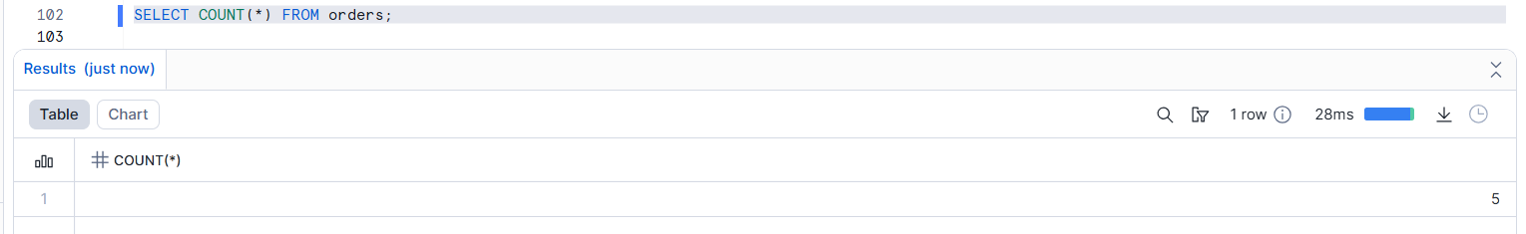
- Result Cache stores the final result of a query for 24 hours and returns it without using compute when the same query is rerun.

8. How does Local Disk Cache differ from Result Cache?
Practical:
Run a query, suspend warehouse, restart it, run the query again, and observe performance change
Answer:
- Result Cache : Stores the final query result, not raw data.
- Local Disk Cache : Stores micro-partitions (raw data) on the warehouse’s local SSD
Run a query (first time) - It is slower,Reads from cloud storage
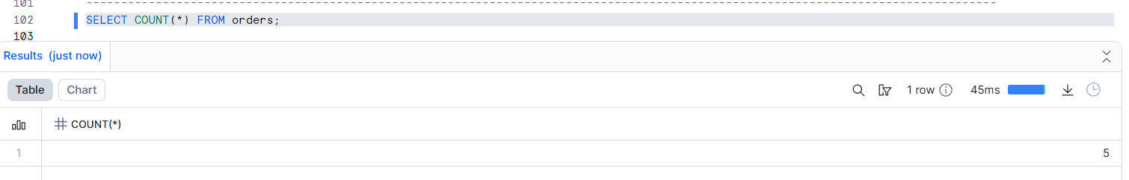

Run the SAME query again - Execution time: milliseconds (Result Cache)
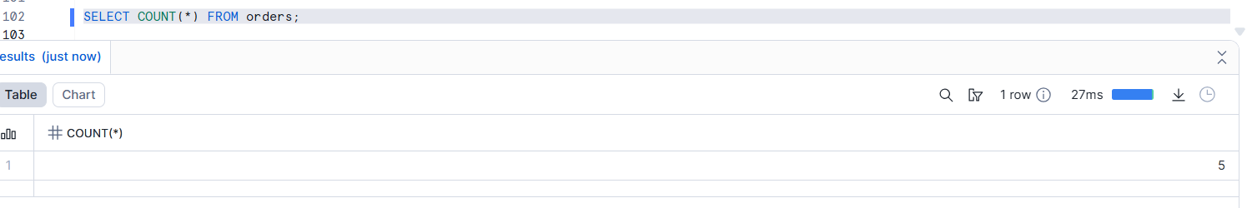
After Suspend Warehouse - Resume Warehouse
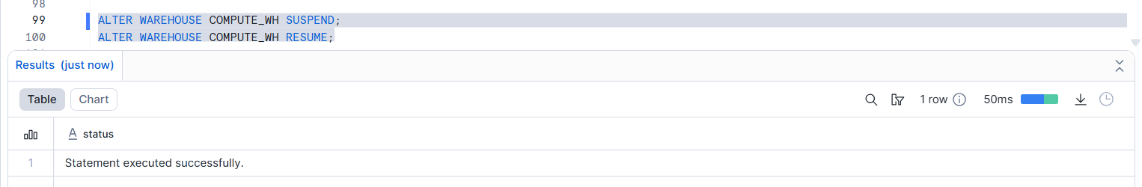
Run again the query - Faster than first run.Slower than result cache
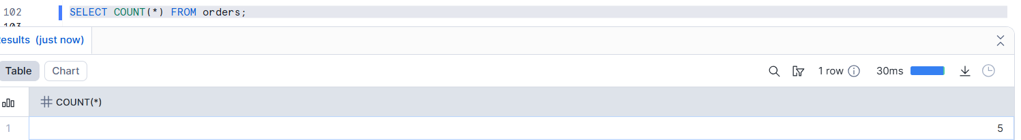
Result Cache stores query results and works even when W.H is stopped, while Local Disk Cache stores data in the W.H memory and is cleared when the warehouse is suspended.

9. What happens to caches when table data changes?
Practical:
Run a query twice, insert new rows, run again and explain why the Result Cache is invalidated and query runs fresh.
Answer:
When table data changes, the Result Cache is invalidated automatically, because Snowflake must return fresh and correct data.
Run Query First Time - Reads from cloud storage
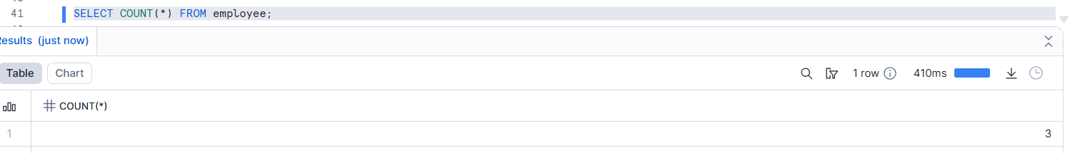

Run Same Query Again - Execution time: milliseconds
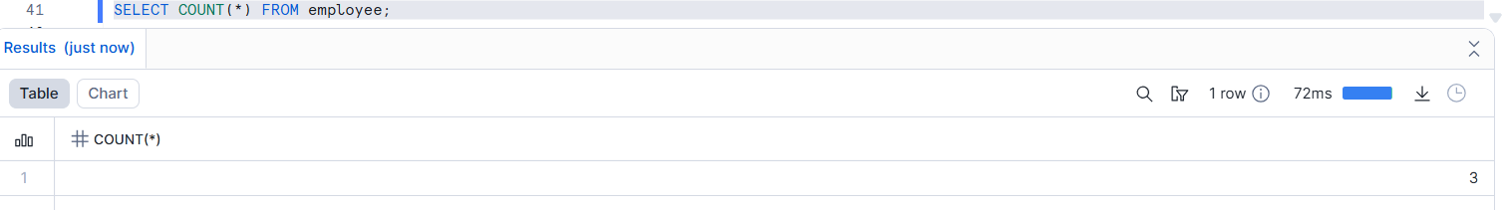
Insert New Data - This modifies table data.Run Same Query Again
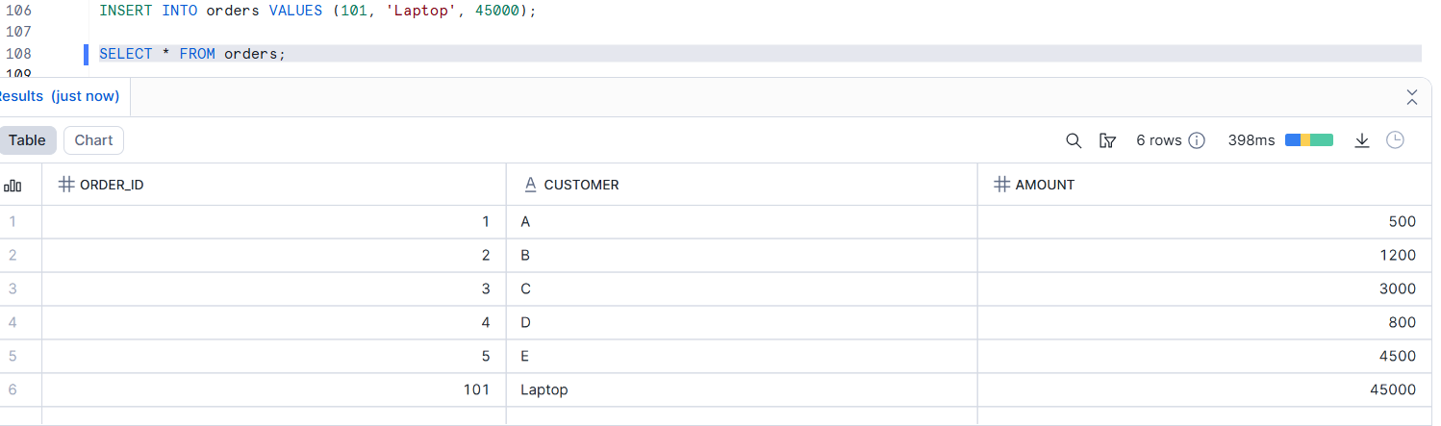
If data changes → result cache breaks
When table data changes, Snowflake invalidates the Result Cache to ensure query results are always accurate, so the query is executed again using fresh data.

10. Describe the difference between first and second run of the same query.
Practical:
Run a query once (full compute), then immediately run again (Result Cache), and explain the difference in resource usage.
Answer:
First run uses compute and scans data . Second run uses Result Cache (no compute).

Run the query (First Time) - Work is done


Run the SAME query again immediately - Answer reused

In the first run, Snowflake scans data and uses compute, while in the second run, it returns the result from cache without using the warehouse, making it much faster and cost-efficient.

11. How does Snowflake’s compute scaling work?
Practical:
Run a complex query on a small warehouse, then increase warehouse size and rerun the query, observing improved speed.
Answer:
Snowflake compute scaling means increasing or decreasing warehouse size to control query performance.
- Bigger warehouse → Faster queries
- Smaller warehouse → Lower cost
- Data storage is not affected
Run Query on Small Warehouse and also run a complex query
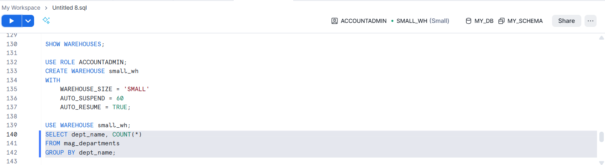
Query runs slow - Limited CPU & memory - More execution time

Increase Warehouse Size
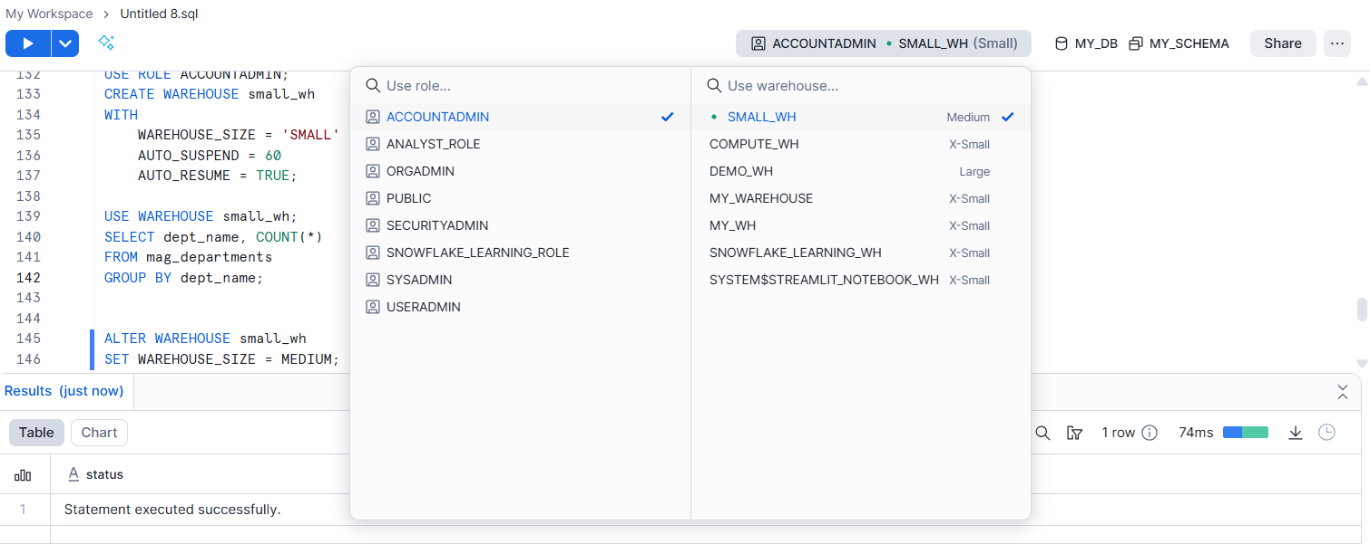
Run the Same Query Again
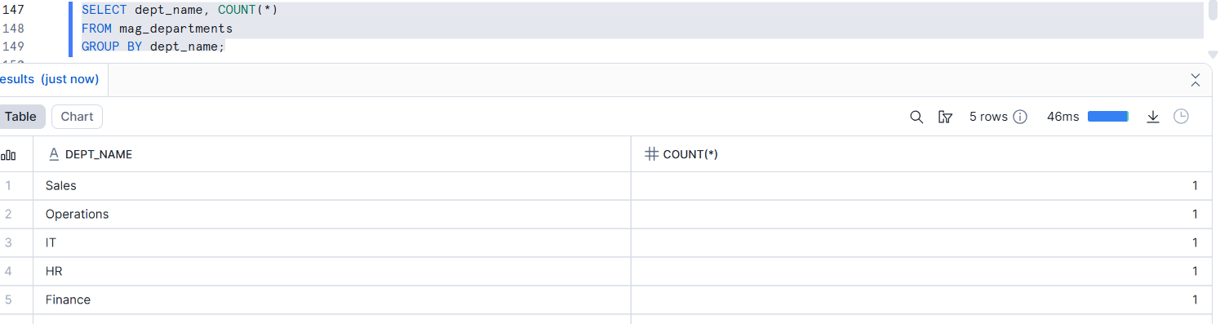Query runs fast - More parallel process - Same data, same query - Higher compute usage

12. Explain external stage vs internal stage.
Practical:
Create an internal stage and upload a file. Create an external stage pointing to S3 and explain the differences.
Answer:
- Internal Stage → Storage managed inside Snowflake
- External Stage → Storage located outside Snowflake (S3, Azure, GCS)

Create an Internal Stage & Upload File - I upload directly into snowflake
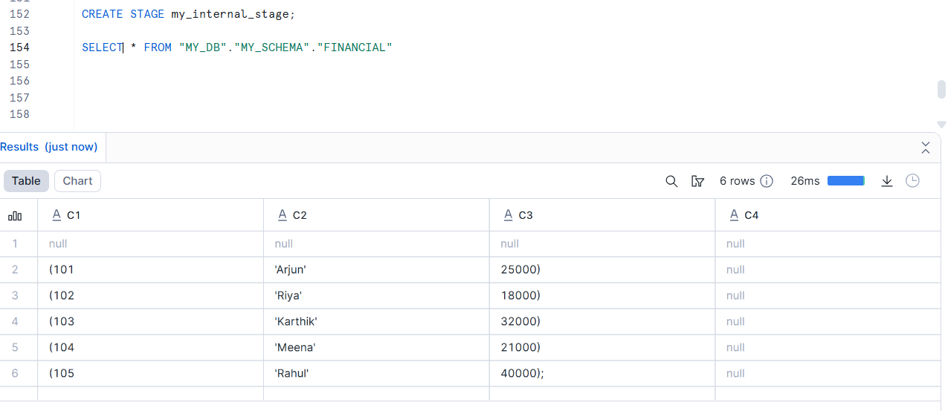
Create an external stage pointing to S3 bucket

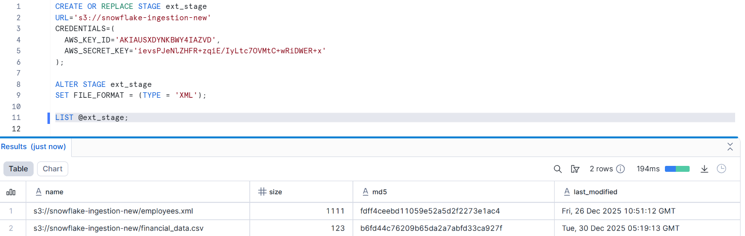

13. Explain the statement:
“Data never moves, compute comes and goes.”
Practical:
Show data stored in table remains the same regardless of warehouse start/stop and resizing.
Answer:
- In Snowflake, data is stored separately from compute.
- Compute (warehouse) can be started, stopped, or resized without affecting data.
- Data = Permanent ; Compute = Temporary

Create a Table and Insert Data - Check data
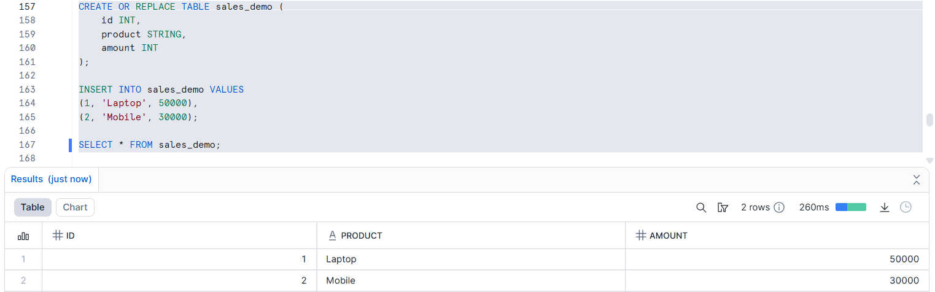

Suspend - Compute stopped , Data still stored safely and Resume the warehouse
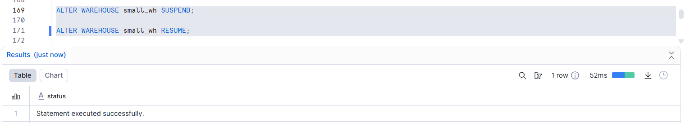
Run Query Again - Data is still there,Only compute restarted.
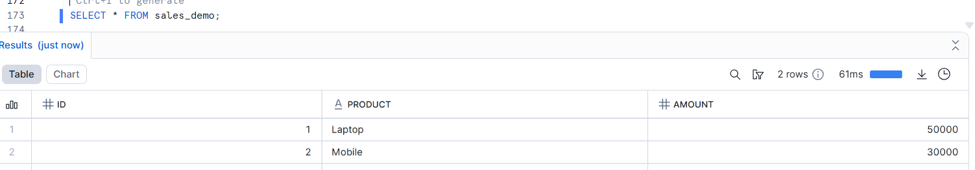
Resize Warehouse , Run query again - Data unchanged , Query runs faster- Only compute increased
